**Digital Learning**

**A PROJECT REPORT**

***Submitted by***

**Priyanshi Shah**

**Varun Shah**

***In fulfilment for the award of the degree***

***of***

**BACHELOR OF ENGINEERING**

***in***

Computer Engineering



LDRP Institute of Technology and Research,Gandhinagar

**Gujarat Technological University, Ahmedabad**

Nov-Dec, 2014

***LDRP Institute of Technology and Research***

***Gandhinagar***

**CE-IT Department**



CERTIFICATE

This is to certify that the Project Work entitled **“Digital Learning ”** has been carried out by**Priyanshi Shah(110300107019) and Varun Shah(110300107020)** under my guidance in fulfilment of the degree of Bachelor of Engineering in Computer Engineering/Information Technology (7th Semester) of Gujarat Technological University, Ahmedabad during the academic year 2014-15.

**Guides:**

Prof Abhinay Pandya, Prof. A. K. Goyal

LDRP-ITR **Head of the Department**

**TABLE OF CONTENTS:**

Acknowledgement

Abstract

Table of Contents

List of Figures

List of Tables

1. **Introduction**
   1. Introduction
   2. Scope
   3. Project summary and Purpose

1.4 Overview of the project

* 1. Problem definition

1. **Technology and Literature Review**
   1. About Tools and Technology
2. **System Requirements Study**
   1. User Characteristics
   2. Hardware and Software Requirements
   3. Constraints
      1. Regulatory Policies
      2. Hardware Limitations
      3. Interfaces to Other Applications
      4. Parallel Operations
      5. Higher Order Language Requirements
      6. Reliability Requirements
      7. Criticality of the Application
      8. Safety and Security Consideration
3. **System Requirement**

4.1 Brief History of Work Done

4.2 Project Planning & Scheduling

4.2.1 Project Development Approach

4.3 Risk Management

4.3.1 Risk Identification

4.3.2 Risk Analysis

4.3.3 Risk Monitoring

4.4 System Requirement Study

4.4.1 User Characteristics

4.4.2 Feasibility Study

4.4.2.1 Technical Feasibility

4.4.2.2 Economic Feasibility

4.4.3 Operational Feasibility

4.4.4 Functional Requirements

4.5 System Analysis

4.5.1 Study of Current System

4.5.2 Problems & Weaknesses of Current System

4.5.3 Features of new System

4.5.4 Requirements of new System

4.5.4.1 User Requirements

4.5.5 Requirement Validation

1. **System Design**

5.1 Class Diagram

5.2 Use case diagram

5.3 Sequence Diagram

5.4 Activity Diagram

5.5 State Diagram

5.6 Data Dictionary

1. **Screenshots**
2. **Conclusion**
3. **Bibliography**

Appendix A: Patent Search Analysis Report (all patent report downloaded from GTU.)

# -: ACKNOWLEDGEMENT:-

I take this opportunity to humbly express our thankfulness to all those concerned with my project.

First of all I am thankful to **LDRP-ITR** for undertaking this project. I am sincerely indebted to**Prof. Abhinay Pandya** for giving me the opportunity to work on this project. Her continuous guidance and help have proved to be a key to my success in overcoming the challenges that I have faced during my project work. Her support made the project a pleasantly memorable one .Without her help at all stages in spite of her own work load; the completion of the project would not have been possible.

I express my sincere gratitude to **Prof. A. K. GOYAL** for his valuable guidance and positive feedback.

There are so many people without whose help I would never have conceived and learnt, to whom I would like to express my gratitude – my friends , colleagues, and of course CE & IT Department of LDRP-ITR.

Last but not least I am thankful to almighty GOD and my PARENTS for giving me such a good atmosphere to work hard and to succeed.

**With regards,**

**Priyanshi Shah**

**Varun Shah**

--------------------------------------

**ABSTRACT**

**Digital Learning**

Digital Learning is any instructional practice that uses technology to strengthen a student's learning experience. It is an Android app which emphasizes high-quality instructions and provides access to challenging contents, feedback through formative assessment, opportunities for learning. Results can be easily evaluated by the teachers. This is an Application that would generate interest towards students.

**Priyanshi Shah(110300107019)**

**Varun Shah(110300107020)**

1. **LIST OF FIGURE:-**

|  |  |  |  |
| --- | --- | --- | --- |
| **No.** | **Figure Name** | **Figure no.** | **Page no.** |
| 1 | Schedule Representation | 4.1 | 21 |
| 2 | Waterfall Model | 4.2 | 22 |
| 3 | Incremental Model | 4.3 | 23 |
| 4 | Risk Management | 4.4 | 24 |
| 5 | Class diagram | 5.1 | 30 |
| 6 | Use case diagram for launcher and users(student & teacher) | 5.2.1,5.2.2,5.2.3 | 31-33 |
| 7 | Sequence diagram for Teacher Mode,Student Mode,Parents | 5.3.1,5.3.2 | 34-35 |
| 8 | Activity diagram for Generating Reports | 5.4.1,5.4.2 | 36-37 |
| 9 | State Diagram for launcher, Teacher,Establishing Connection,Learning procedure. | 5.5.1,5.5.2 | 38-39 |

1. **LIST OF TABLE:-**

|  |  |  |  |
| --- | --- | --- | --- |
| **No.** | **Table Name** | **Table no.** | **Page no.** |
| 1 | ABBREVIATIONS | 1 | 8 |
| 2 | Notation | 2 | 8 |
| 3 | Project Profile | 1.1 | 12 |
| 4 | Data dictionary | 5.6 | 40 |

1. **ABBREVIATIONS**

|  |  |
| --- | --- |
| GUI | Graphical User Interface |
| HTTP | Hyper Text Transfer Protocol |
| DFD | Data Flow Diagram |
| JEE | Java Enterprise Edition |

1. **NOTATIONS**

|  |  |  |
| --- | --- | --- |
|  | Generalization | |
|  | Binary Association | |
|  | Class | |
|  | Dependency |
|  | End Association |
|  | Actor |
|  | Uses |
|  | System Boundary |
|  | Action State |
|  | Control Flow |
|  | Initial State |
|  | Final State |
|  | Fork |
|  | Object Lifetime |
|  | Activation |
|  | Message |
|  | Decision |
|  | State |
|  | Transition |
|  | Actor |
|  | Data Process |
|  | Data Flow |
|  | Data Store |

**Chapter 1**

**Introduction**

🡺 Introduction

🡺Scope

🡺Project Summary and Purpose

🡺Overview of the project

🡺Problem definition

**1.1 Introduction:-**

|  |  |
| --- | --- |
| **Project Title :** | **Digital Learning** |
| **Organization:** | **LDRP INSTITUTE OF TECHNOLOGY AND RESEARCH** |
| **Tools :** | **Hardware**   * Rooted Android Tablet * 1GB RAM (Recommended) * 8GB Internal Memory (Recommended)   **Software**   * **DevelopmentTool:**   + - IntelliJ IDEA     - Android Studio * **Database Tool:**   + - MY SQL     - Sql Lite     - **Software :**     - Sdk 16(min) |
| **Team Size :** | 2 persons |
| **Team Members:** | Priyanshi Shah  Varun Shah |
| **Guided By :** | Prof. Abhinay Pandya |
| **Submitted To:** | DEPARTMENT OF COMPUTER ENGINEERING & INFORMATION TECHNOLOGY,  LDRP INSTITUTE OF TECHNOLOGY & RESEARCH, GANDHINAGAR |

**Table 1.1: Project Profile**

**1.2 PROJECT SCOPE:-**

• To improve student's learning through technology:

Students can easily connect to the teachers, by their Tablets.

The application also provides, to choose the appropriate task.

• To serve the students, in best manner:

Students can ask their query to teacher through client server communication.

**1.3 PROJECT SUMMARY AND PURPOSE:-**

**Summary :**

This Application provides an interface from which student can improve their grasping power. This application provides images to fill colors and connect dots etc different tasks which can make them imaginative and creative. They can learn to identify real world objects. The drawing task can help to learn alphabets and many different entities.

More Importantly Students don’t have to raise hand for query and wait for teacher to be available. They can send query to their teacher and teacher will reply accordingly.

**Purpose :**

A one-stop, all-in-one Application will be provided which will include all the possible enhancements needed for a particular college. It will have all the facilities that the users of the system require to make education and also the communications easier.

Education is the most powerful weapon which you can use to change the world. This Application can be a blessing for the students of the institution.

**1.4 Overview of the project :-**

The purpose of Project, is to provide Effective communication between mobile devices without using external router or wifi. As connection between master and clients is established, data can be shared by clients. Master will be able to broadcast messages or content connected to clients(nodes).Client will be able to identify master and will be able to connect as and when master is available. One click installer, which will act as a master or node based on configuration. Configurations are required to set after installation.

As the number of Internet access points are growing rapidly, Digital-Learning is also gaining a new peak. It provides the best medium between students and teacher, with the help of rich multimedia.

**1.5 Problem Definition :-**

Digital Learning is any instructional practice that uses technology to strengthen a student's learning experience. It emphasizes high-quality instruction and provides access to challenging content, feedback through formative assessment, opportunities for learning.

• One click installer, which will act as a master or node based on configuration. Configurations required to set after installation.

• As connection between master and clients is established, data can be shared by clients.

• Master will be able to broadcast messages or content connected to clients(nodes).

• Students will learn their course thoroughly according to the tasks given in the application.

**Chapter 2**

**Technology&Literature Review**

* 1. **About Tools and Technology**
  2. **About Tools and Technology :**

About Tools and Technology

Platform: Android

Hardware Peripherals: A booted wi-fi configured Tablet.

Softwares Used:

IDE : IntelliJ IDEA , Android Studio

**Chapter 3**

**System Requirement Study**

`` 3.1 User Characteristics

3.2 Hardware and Software Requirements

3.3 Constraints

3.3.1 Regulatory Policies

3.3.2 Hardware Limitations

3.3.3 Interfaces to Other Applications

3.3.4 Higher Order Language Requirements

3.3.5 Reliability Requirements

3.3.6 Criticality of the Application

3.3.7 Safety and security considerations

**3.1 USER CHARACTERISTICS :**

* This Application can be used by all the faculties, students and parents without having internet connection.

**3.2 HARDWARE REQUIREMENTS :**

* As we are preparing a Android system, obviously the most basic hardware need of the system is a Wireless Rooted Tablet. The recommended requirements are as follows :

**For user :**

* **RAM :** 1GB or more
* **Sdk:** API 16 or above
* **Device:** Booted Wireless Tablet

**For developer :**

* **RAM :** 1GB or more
* **Hard disk :** 8 GB
* **Sdk:** API 16 or above
* **Device:** Booted Wireless Tablet

**SOFTWARE REQUIREMENTS :**

**For developer :**

* **Tools :** Sdk API 16 , IntelliJ Idea, Android Studio
* **Database :** MySQL tool, SQL lite

**3.3 Constraints :**

**3.3.1 Regulatory Policies :**

* This Application has to be purchased by the university or school it is developed for. People related to that institute will be using it.

**3.3.2 Hardware Limitations :**

* Tablet should have more than 8 gb internal memory for better performance.
* 1 Gb Ram is mandatory for the the better performance.
* SDK should be greater than or equals to 16.

**3.3.3 Interfaces to other applications :**

* In this application Master should be connected to Slaves consistently while studying.

**3.3.4 Higher order language requirements :**

* This Application needs to work with java libraries to work with functions not provided in the framework or Intellij IDE.

**3.3.5 Reliability Requirements :**

* This Application is very reliable and hence, no special requirements are needed.

**3.3.6 Criticality of the Application :**

* If the Required Configured Device is not used then There is a chance of device getting hang.

**3.3.7 Safety and security considerations :**

* The user should have a stable internet connection. Other than that, the user should Required Configured Device.

**Chapter 4**

**System Requirement**

4.1 Brief History of Work Done

4.2 Project Planning & Scheduling

4.2.1 Project Development Approach

4.3 Risk Management

4.3.1 Risk Identification

4.3.2 Risk Analysis

4.3.3 Risk Monitoring

4.4 System Requirement Study

4.4.1 User Characteristics

4.4.2 Feasibility Study

4.4.2.1 Technical Feasibility

4.4.2.2 Economic Feasibility

4.4.3 Operational Feasibility

4.4.4 Functional Requirements

4.5 System Analysis

4.5.1 Study of Current System

4.5.2 Problems& Weaknesses of Current System

4.5.3 Features of new System

4.5.4 Requirements of new System

4.5.4.1 User Requirements

4.5.5 Requirement Validation

**4.1 Brief History of Work Done :-**

* **Milestones and Deliverables:**

The project is planned to complete in a particular time interval. For the delivery of the project, some milestones are required to indicate status of project.

We have defined it for our project as per requirement and planning. These milestones are given below:

1. The completion of Project and Domain analysis for project.

• Delivered: 25th July,2014

2. Detailed study and analysis of requirements.

- Comparing with other systems.

-defining main modules of the system.

• Delivered:23rd September, 2014

3. Database design and creation of Data Dictionary.

• Delivered:10th October, 2014

4. Design the system and represent the system in form of Diagrams.

• Delivered:20th October, 2014

5. Development of project.

- Coding and Deployment.

- Testing

• Delivered: May ,2015

* **Schedule Representation** :-

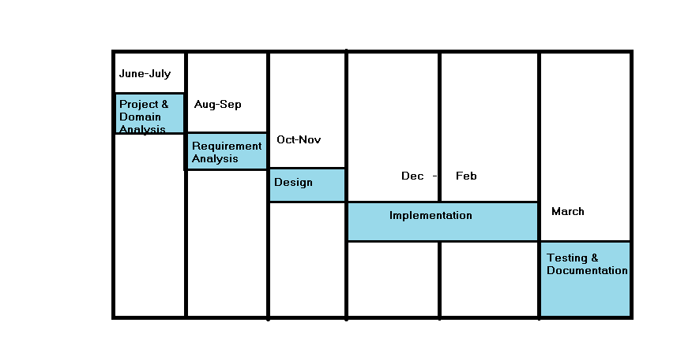

**Fig 4.1 : Schedule Representation**

**4.2 Project Planning and Scheduling :-**

**4.2.1 Project Development Approach**

Project management is the discipline of planning, organizing, securing & managing resources to bring about the successful completion of specific project goals and objectives.It is sometimes conflated with program management, however technically that is actually a higher level construction: a group of related and somehow interdependent engineering projects.

The primary challenge of project management is to achieve all of the project goals and objectives while honouring the preconceived project constraints. Typical constraints are scope,time, and budget. The secondary—and more ambitious—challenge is to optimize the allocation and integration of inputs necessary to meet pre-defined objectives.

Project planning is a development strategy that is used to achieve a goal that satisfies

the requirements abiding by the constraints. There are many types of software process models

like linear sequential model, RAD model, incremental model, spiral model etc. By this process model we can easily make a good planning for the project we have decided to use the **WaterfallModel** for our project.

As we working on an online project and we have a time of 1 year, we are using the

waterfall model.



**Fig 4.2 : Waterfall Model**

In the Software Development Life Cycle, there are different stages for requirement collection,

analysis, design, coding, implementation and testing. We first identify the client requirements

and perform feasibility study. After all the requirements have been accumulated, the analysis

phase is entered into and the system is designed after thorough understanding of the system.

Once designing is completed the actual implementation of the software takes place. Along with the coding we also employ unit testing methods to uncover errors before they propagate to the next level. After the system is completely coded, we employ system testing to test the system as a whole.

**Incrementalmodel:-**

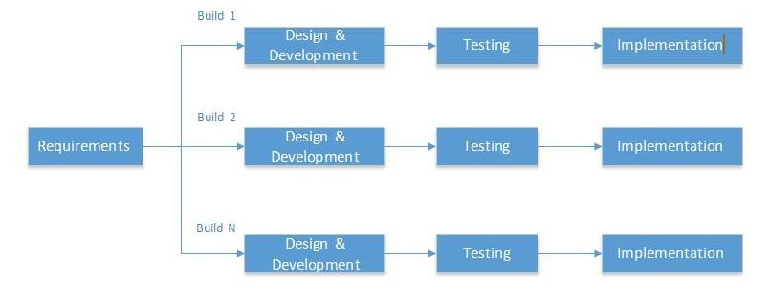

**Fig 4.3 : Incremental Model**

**JUSTIFICATION**

The Incremental model combines elements of the linear sequential model with the iterative philosophy of the prototyping. This model has been explicitly designed to accommodate a product that evolves over time.

When an incremental model is used, the first increment is often a core product. The core product is used by the customer or undergoes a detailed review. As a result of use and/or evaluation a plan is developed for the next increment. The plan addresses the modification to the core product to better meet the needs of the customer and delivery of additional features and functionality. Software is constructed in a step-by-step manner. While a software product is being developed, each step adds to what has already been completed.

**Advantages of Incremental Model**

* System is developed and delivered in increments after establishing an overall architecture. Requirements and specifications for each increment may be developed.
* Users may experiment with delivered increments while others are being developed.
* Intended to combine some of the advantages of prototyping but with a more manageable process and better system structure.
* Incremental development is especially useful when staffing is unavailable for a complete implementation by the business deadline. Early increments can be implemented with fewer people.

**4.3 Risk Management :-**

Risk analysis and management are a series of steps that help a software team to understand and manage uncertainty. Many problems can plague a software project. A risk is a potential problem—it might happen, it might not. But, regardless of the outcome, it’s a really good idea to identify it, assess its probability of occurrence, estimate its impact, and establish a contingency plan should the problem actually occur.



**Fig 4.4 : Risk Management**

**4.3.1 Risk Identification**

During the project plan we have consider all the proactive which we have think we will face during the project period. Here I have listed the risks which we have considered during the project plan:

* Possibility that the components are not available during the project period.
* Possibility that software purchased was not compatible.
* Possibility that the hardware resources are not available during the project period.

**4.3.2 Risk Analysis**

A project can get affected by a large variety of risks. In order to be able to systematically identify the important risk which might affect the project it is necessary to categorize risks into different classes which we will discuss in next section. During Risk analysis process, each identified risk is considered in turn and judgment is made about the probability and the seriousness of the risk.

**4.3.3 Risk Monitoring**

Risk Monitoring involves regularly assessing each of the identified risks to decide whether or not that risk is becoming more or less probable and whether the effects of the risk have changed.

**4.4 System Requirements Study :-**

**4.4.1 User Characteristics**

Because of its nature, potential users of E-society project can be categorized in three distinct

groups.

* Developers/Admin
* Development, hosting and maintenance will be done by the development team.
* Registered Users : -
* System is made for faculties and students of the Institutes. They can use the functionality provided by the system.

**4.4.2 Feasibility Study**

Feasibility study is carried out whenever there is a complex problem or opportunity; it is a preliminary investigation that emphasizes to determine the possibility or probability of either improving the existing system or developing a completely new system. It helps to obtain an overview of the problem and to get rough assessment of whether feasible solution exits. This is essential to avoid committing large resources to a project and the repent on it later.

Feasibility study is needed to

* Determine the potential of the existing system
* Improve the existing system
* Know what should be embedded in to new system?
* Define the problems and objectives involved in a projects
* Avoid crash implementation of new systems
* Avoid costly repairs at a later stage when the system is implemented

**4.4.2.1 Technical Feasibility**

It is concerned with specifying equipment and software that will successfully support the required pack. It centres on the requirement of existing software and to what extent it can support the proposed application.

**4.4.2.2 Economic Feasibility**

The purpose of assessing economic feasibility is to identify the financial benefits and cost associated with the development project. Economy feasibility is often known as cost benefit analysis.

**4.4.3 Operational Feasibility**

Operational feasibility is concerned with human organization and political aspects. Operational feasibility covers two aspects, one is technical performance and the other is acceptance within the organization. Technical performance includes issues such as determining whether the system can provide the right information for organization’s personnel or not. Operational feasibility must determine how the proposed system will fit in with the current operations.

**4.5 System Analysis :-**

**4.5.1 Study Of Current System :**

This Application provides an interface from which student can improve their grasping power. This application provides images to fill colors and connect dots etc different tasks which can make them imaginative and creative. They can learn to identify real world objects. The drawing task can help to learn alphabets and many different entities.

More Importantly Students don’t have to raise hand for query and wait for teacher to be available. They can send query to their teacher and teacher will reply accordingly.

**4.5.2 Problems and weaknesses of current System**

The conventional systems available currently have the following weakness:

* No availability of all the updated information of students to the faculties and system.
* No practical Knowledge.
* Retrieval of information is time consuming.
* Handling of account is cumbersome.
* Non-Interactive Sessions.
* Teacher won’t be able to concentrate on all students altogether.

**4.5.3 Features Of New System**

* Application provides different tasks that can help them in improve their ability.
* Students can send query via message.

**4.5.4 Requirements of New System**

**4.5.4.1 User Requirements :-**

Student :-

* Choose Task
* Connect to Teacher Device
* Disconnect to Teacher Device
* Sends query to teacher

Teacher:-

* Analysing the students' performace on regular basis
* Create Connection to all Students
* Broadcast message to students

**4.5.5 Requirements Validation :-**

* It means that the created mobile application is as per requirement or not? Simply starting whatever we are doing is right or wrong as per requirement? Here we check each & every requirement & compare with our Application & that it satisfies the user need.
* Requirements validation is concerned with showing that the requirements actually define the system that user wants. If this validation is inadequate, errors in the requirements will be propagated to the system design and implementation.
* Requirements are checked to discover if they are complete, consistent and in accordance with what users want from the projected system.

**Chapter 5**

**System Design**

5.1 Class Diagram

5.2 Use case diagram

5.3 Sequence Diagram

5.4 Activity Diagram

5.5 State Diagram

5.6 Data Dictionary

**5.1 Class Diagram :-**



**Fig 5.1 : Class Diagram**

**5.2 Use case Diagram :-**



**Fig 5.2.1 USECASE DIAGRAM for Students**



**Fig 5.2.2 USECASE DIAGRAM for Registration**



**Fig 5.2.3 USECASE DIAGRAM for Drawing Task**

* 1. **Sequence Diagram :-**



**Fig 5.3.1 : Sequence Diagram for Select User**



**Fig 5.3.2 Sequence Diagram for Registration**

* 1. **Activity Diagram :-**



**Fig 5.4.1 : ACTIVITY DIAGRAM for Student Details**



**Fig 5.4.2 : ACTIVITY DIAGRAM for Student Tasks**

**5.5State Transition Diagram :-**



**Fig 5.5.1 : State Diagram for Student Details**



**Fig 5.5.2 : State Diagram for Registration**

**5.6 Data Dictionary :-**

**5.6.1**

**Table Name : Student_Data**

**Description : This table contains information about Student.**

|  |  |  |  |  |
| --- | --- | --- | --- | --- |
| **Field** | **DataType** | **Size** | **Null** | **Primary**  **Key** |
| id | int | 2 | NO | YES |
| name | varchar | 20 | NO | NO |
| age | varchar | 2 | NO | NO |
| password | Int | 4 | NO | NO |
| image | blob |  | NO | NO |

**Chapter 6**

**Screenshots**

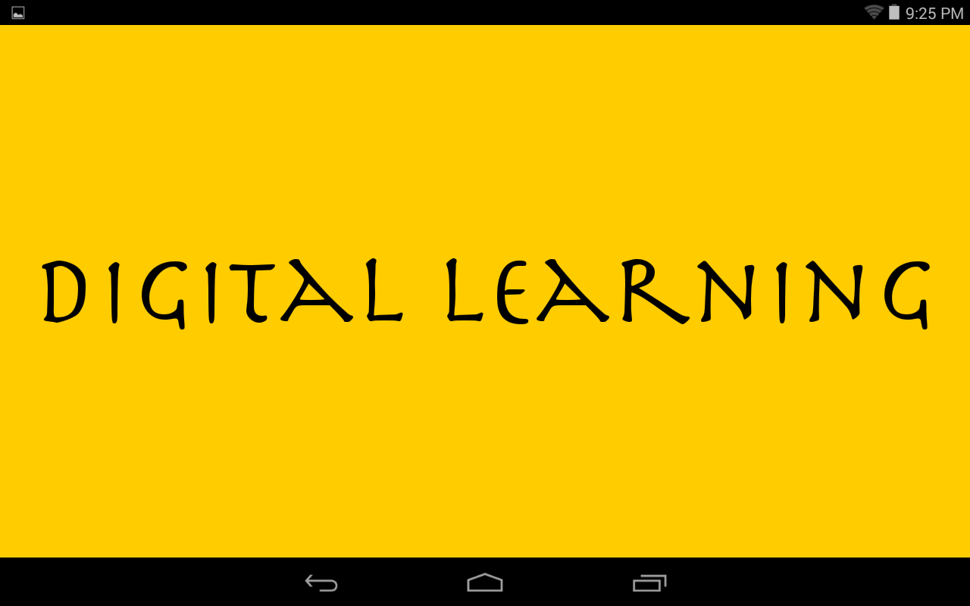

**Fig 6.1 Start Page of Digital Learning**

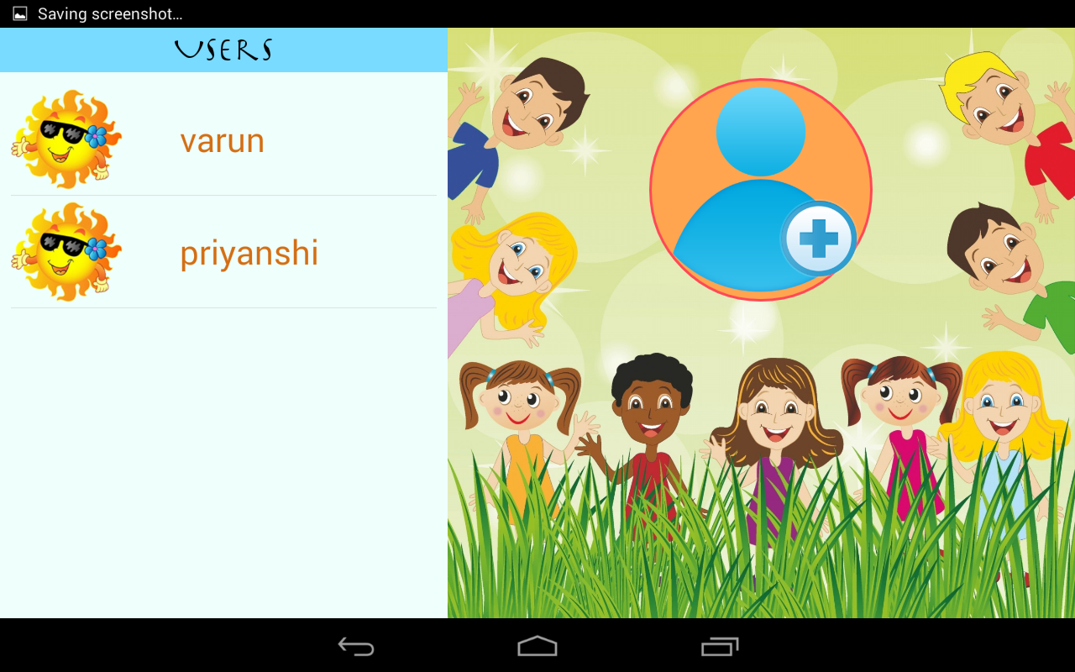

**Fig 6.2 List Of Students**

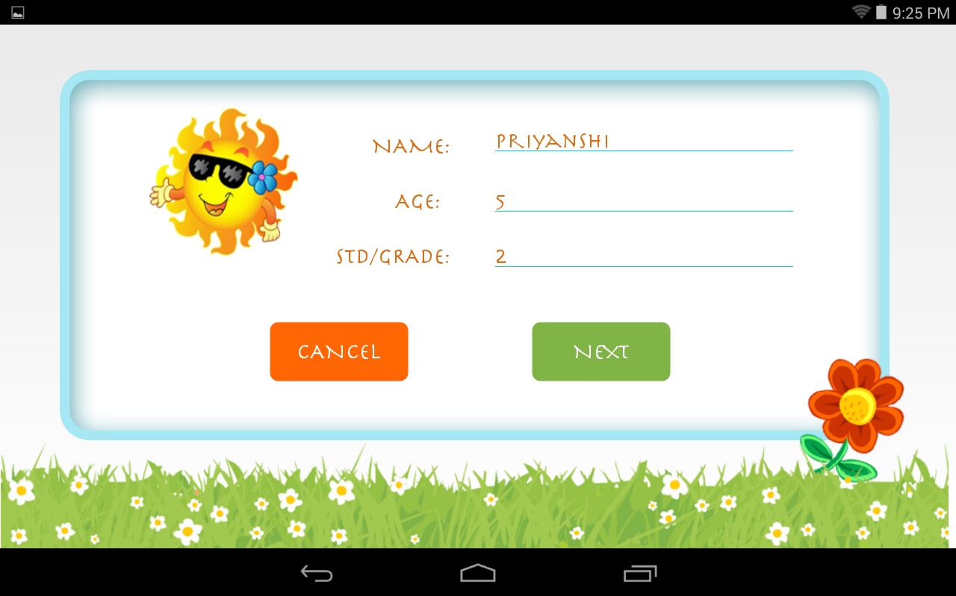

**Fig 6.3 Registration page**

**Fig 6.4 Enter passcode**

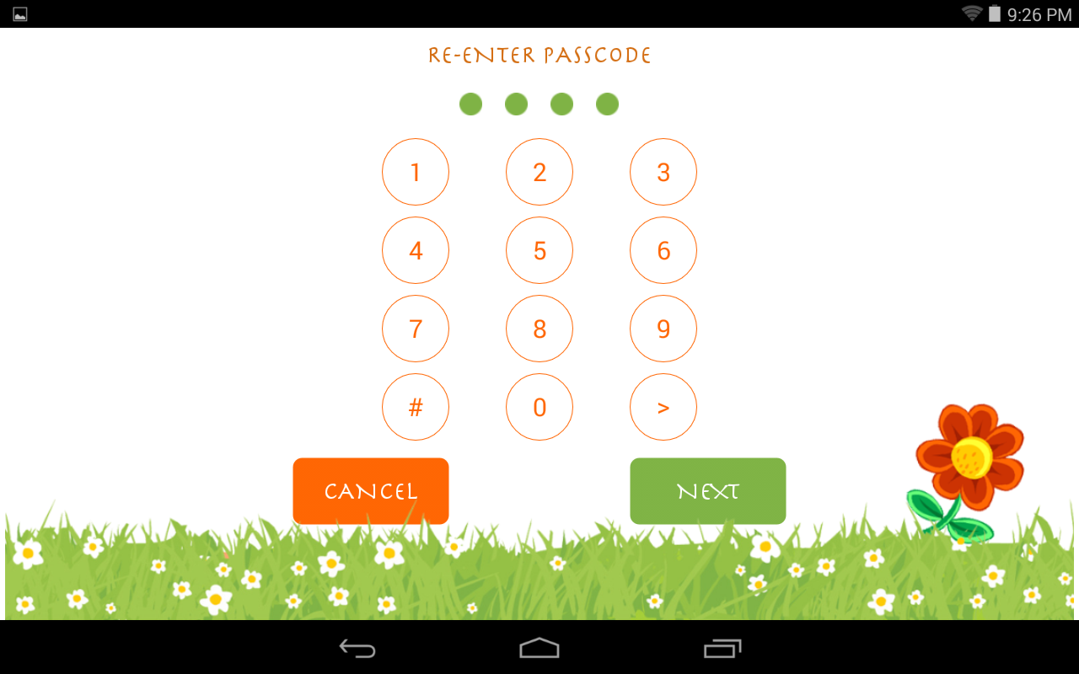

**Fig 6.5 Re-enter Passcode**

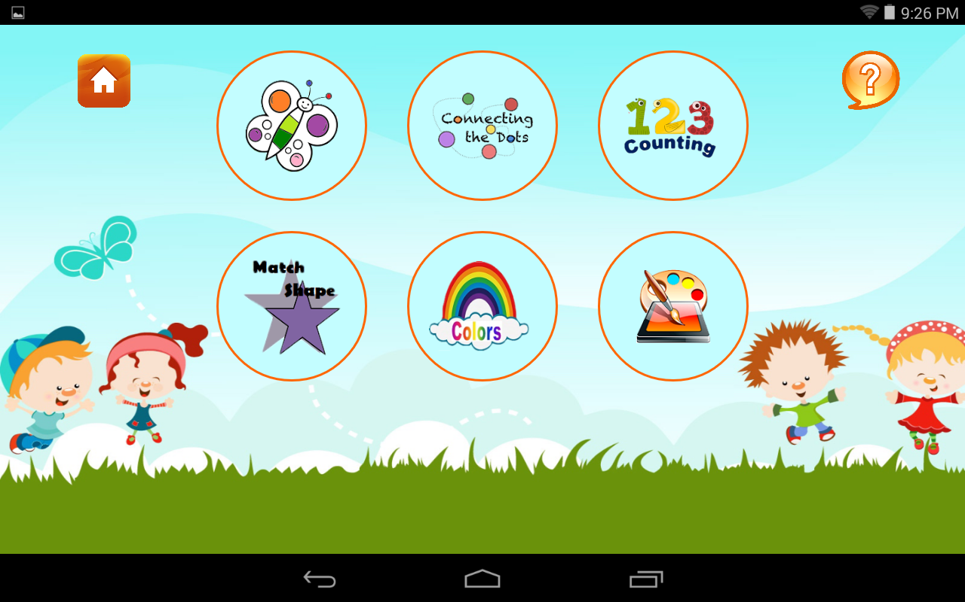

**Fig 6.6 Student Tasks**

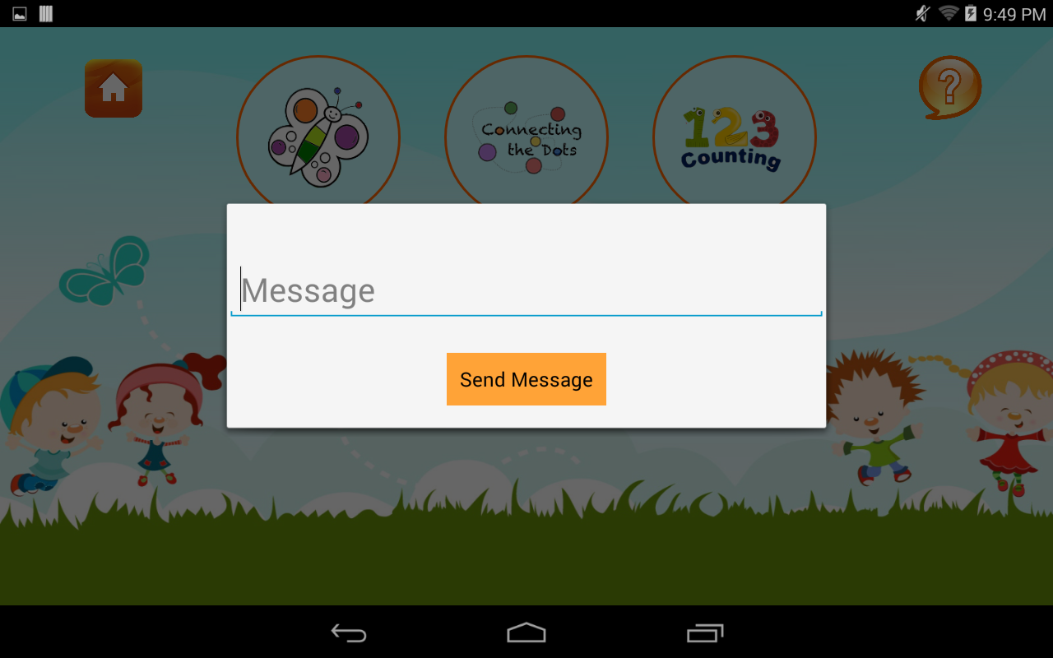

**Fig 6.7 Send Query to Teacher**

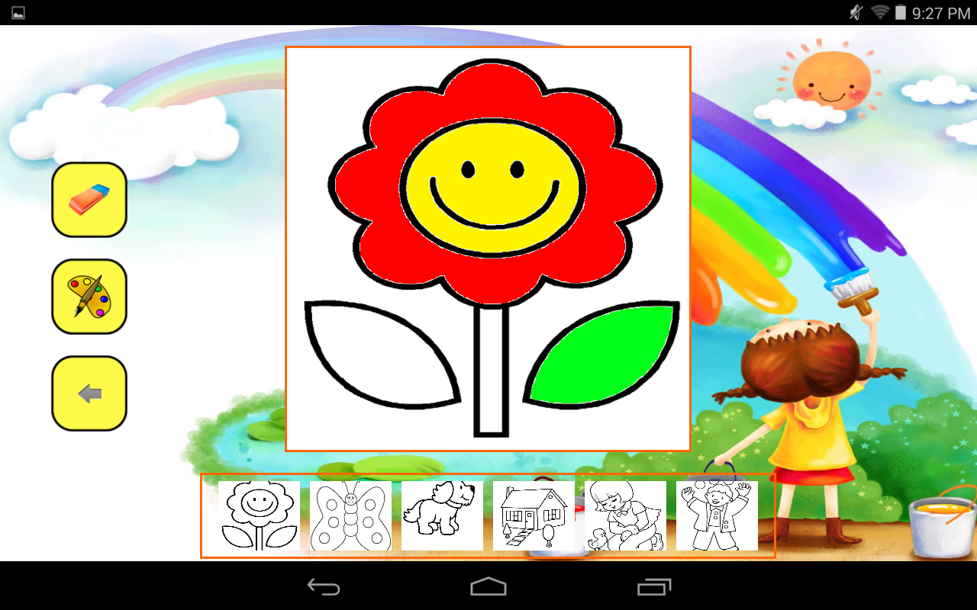

**Fig 6.8 Fill Color**

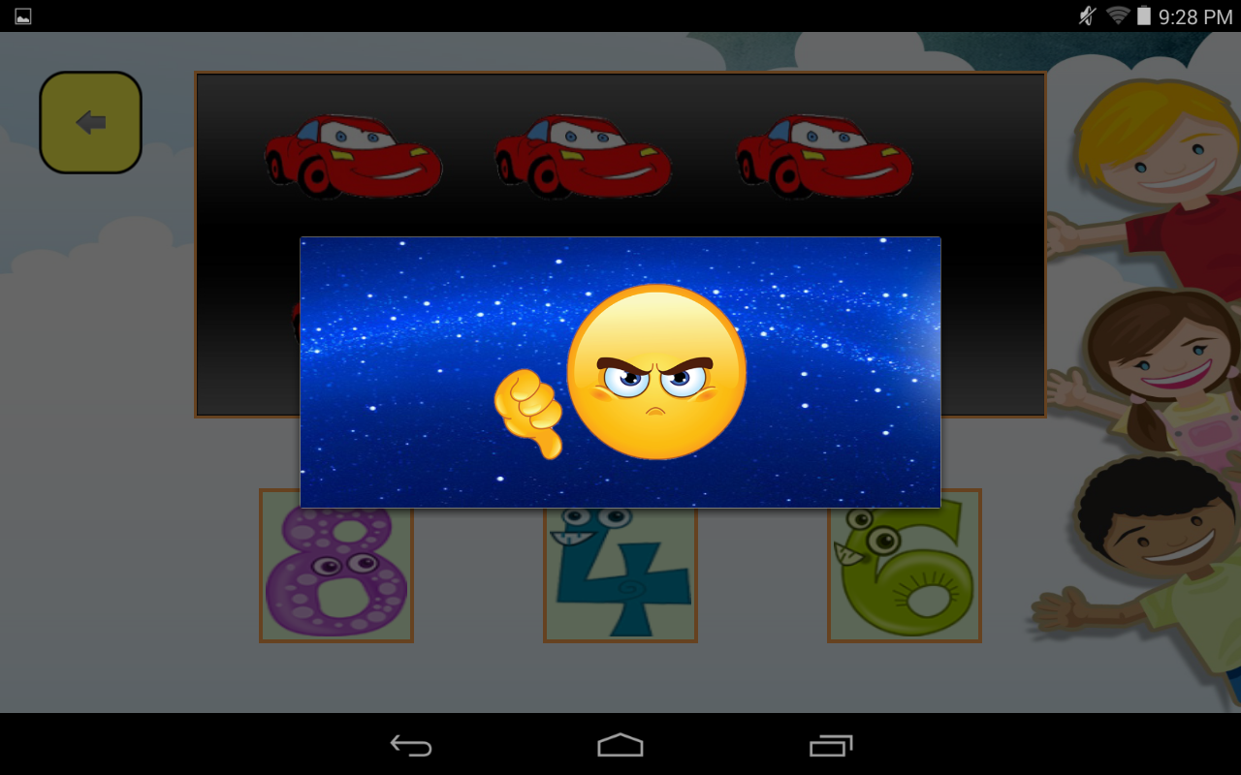

**Fig 6.9 For Incorrect Answer**

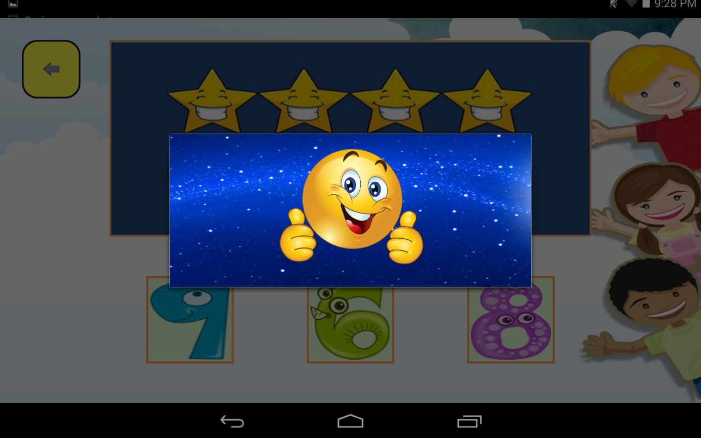

**Fig 6.10 For Correct Answer**

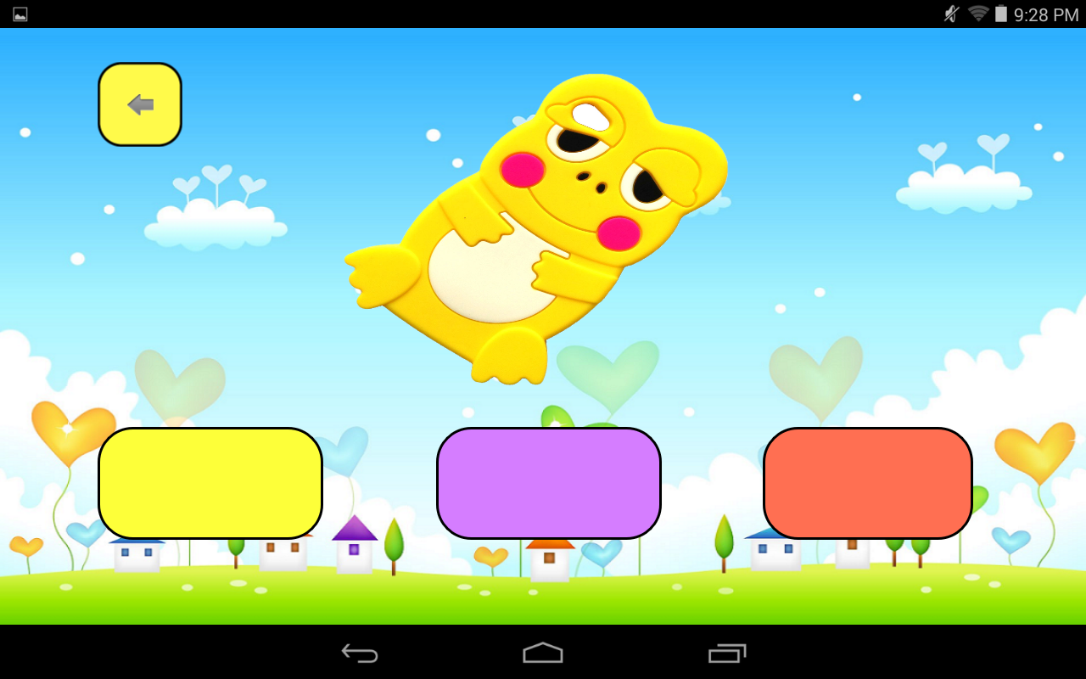

**Fig 6.11 MatchColor**

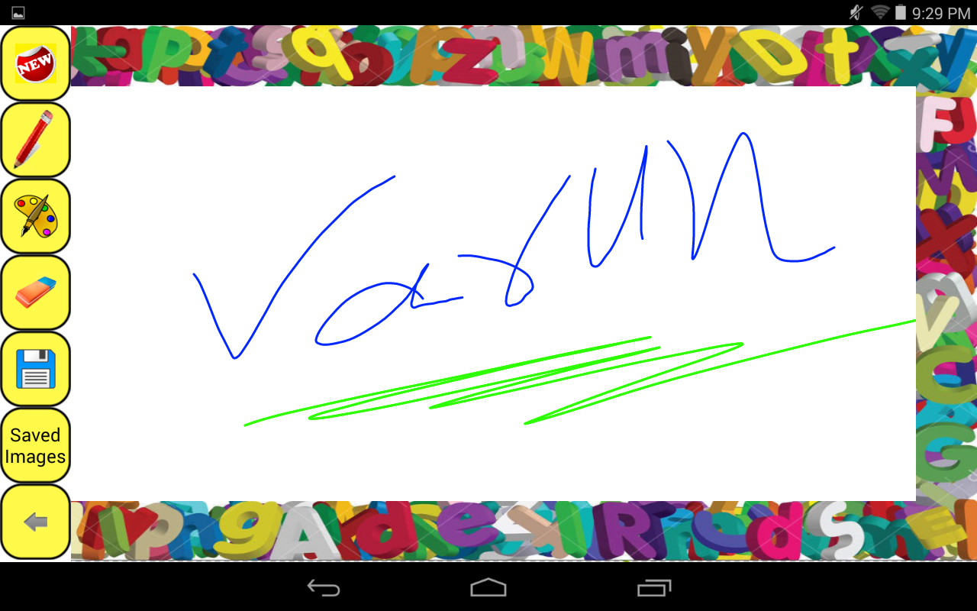

**Fig 6.12 Drawing**

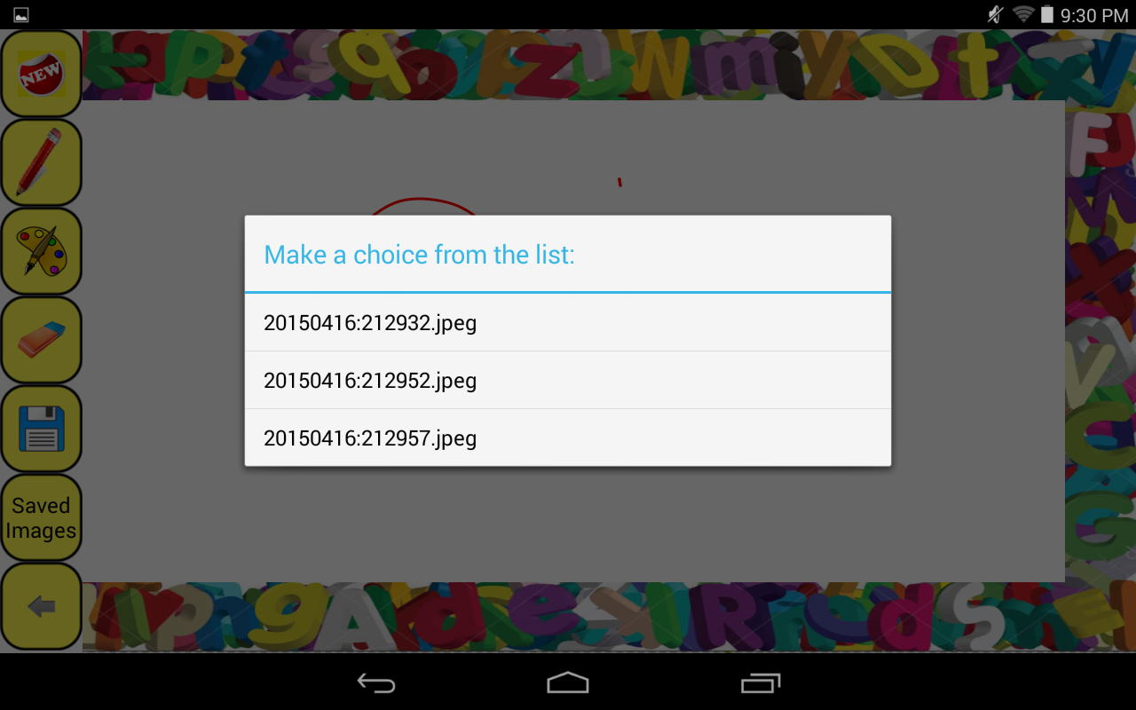

**Fig 6.13 Saved Images of Drawing**

**Chapter 7**

**Conclusion**

**Conclusion :-**

The project DIGITAL LEARNING is made after checking project’s workability in all aspects and in accordance to the users’ requirements with a moderate degree of security mechanisms as well as provision for future enhancements, as they would come with time.

The Digital Learningis an education Applicationsystem improves vastly over the old system, which was inefficient. The project DIGITAL LEARNING is made keeping in mind the present requirements, the lessons learnt from the past system and possible future needs of the users. These Application would generate curiosity in Students to learn their academics in enhanced way. Students can send query message to teacher which teacher will reply accordingly.So students don’t have to wait for teacher to be available. To make DIGITAL LEARNING more flexible for all users, emphasis was on proper management of resources (Device as well as humans) during the analysis as well as the designing too. Thus the system is capable of handling a wide range of enhancements.

Thus, DIGITAL LEARNING hopes to serve the purpose for which it was created well and adapt to the changing requirements in an effective way.

**Chapter 8**

**Bibliography**

**and**

**References**

**Books:-**

* SoftwareEngineering:APractioner’sApproach6theditionbyRogerPressman, McGrawHillinternational edition.
* TheObjectOrientedApproachConcepts,SystemDevelopmentandModellingwith

UML, Satzinger, Orvik,2ndedition.

* JAVA –Complete Reference
* Author Sams, "Teach Yourself Android Application Development in 24 hours”.
* Authored by Ed Burnette, “Hello, Android”.

**References :-**

* [**www.google.com**](http://www.google.com)
* [**jetbrains.com/idea/**](http://www.jetbrains.com/idea/)
* [**developer.android.com**](http://developer.android.com)
* [**www.stackoverflow.com**](http://www.stackoverflow.com)
* [**www.tutorialpoints.com**](http://www.tutorialpoints.com)

**Search Engine**

* Wikipedia
* Google
* Youtube